**Unit Testing with JUnit - Tutorial**

(c) 2007, 2016 vogella GmbH  
version 4.3, 21.06.2016

Table of Contents

* [1. The purpose of software tests](http://www.vogella.com/tutorials/JUnit/article.html#testintroduction)
  + [1.1. What are software tests?](http://www.vogella.com/tutorials/JUnit/article.html#whataresoftwaretests)
  + [1.2. Why are software tests helpful?](http://www.vogella.com/tutorials/JUnit/article.html#whytesting)
  + [1.3. Testing frameworks for Java](http://www.vogella.com/tutorials/JUnit/article.html#testing-frameworks-for-java)
* [2. Testing terminology](http://www.vogella.com/tutorials/JUnit/article.html#testingterminology)
  + [2.1. Code (or application) under test](http://www.vogella.com/tutorials/JUnit/article.html#code-or-application-under-test)
  + [2.2. Test fixture](http://www.vogella.com/tutorials/JUnit/article.html#junit_testfixture)
  + [2.3. Unit tests and unit testing](http://www.vogella.com/tutorials/JUnit/article.html#junit_intro)
  + [2.4. Integration tests](http://www.vogella.com/tutorials/JUnit/article.html#junit_organization)
  + [2.5. Performance tests](http://www.vogella.com/tutorials/JUnit/article.html#junit_performancetests)
  + [2.6. Behavior vs. state testing](http://www.vogella.com/tutorials/JUnit/article.html#behaviorvsstatetesting)
* [3. Test organization](http://www.vogella.com/tutorials/JUnit/article.html#testorganization)
  + [3.1. Where should the test be located?](http://www.vogella.com/tutorials/JUnit/article.html#junit_testorganization)
  + [3.2. Which part of the software should be tested?](http://www.vogella.com/tutorials/JUnit/article.html#junit_whattotest)
* [4. Using JUnit](http://www.vogella.com/tutorials/JUnit/article.html#junittesting)
  + [4.1. The JUnit framework](http://www.vogella.com/tutorials/JUnit/article.html#unittesting_junit)
  + [4.2. How to define a test in JUnit?](http://www.vogella.com/tutorials/JUnit/article.html#unittesting_junit_test)
  + [4.3. Example JUnit test](http://www.vogella.com/tutorials/JUnit/article.html#unittesting_junitexample)
  + [4.4. JUnit naming conventions](http://www.vogella.com/tutorials/JUnit/article.html#junit_namingconventions)
  + [4.5. JUnit naming conventions for Maven](http://www.vogella.com/tutorials/JUnit/article.html#junit_namingconventions_maven)
  + [4.6. JUnit test suites](http://www.vogella.com/tutorials/JUnit/article.html#juniteclipse_testsuite)
  + [4.7. Run your test from the command line](http://www.vogella.com/tutorials/JUnit/article.html#juniteclipse_code)
* [5. Basic JUnit code constructs](http://www.vogella.com/tutorials/JUnit/article.html#junitannoationsandassertstatements)
  + [5.1. Available JUnit annotations](http://www.vogella.com/tutorials/JUnit/article.html#usingjunit_annotations)
  + [5.2. Assert statements](http://www.vogella.com/tutorials/JUnit/article.html#usingjunit_asserts)
  + [5.3. Test execution order](http://www.vogella.com/tutorials/JUnit/article.html#usingjunit_executionorder)
  + [5.4. Disabling tests](http://www.vogella.com/tutorials/JUnit/article.html#junit_disablingtests)
* [6. Eclipse support for JUnit](http://www.vogella.com/tutorials/JUnit/article.html#eclipse-support-for-junit)
  + [6.1. Creating JUnit tests](http://www.vogella.com/tutorials/JUnit/article.html#eclipse_creatingjunittest)
  + [6.2. Running JUnit tests](http://www.vogella.com/tutorials/JUnit/article.html#running-junit-tests)
  + [6.3. Extracting the failed test and stacktraces](http://www.vogella.com/tutorials/JUnit/article.html#usingjunit_failedtests)
  + [6.4. JUnit static imports](http://www.vogella.com/tutorials/JUnit/article.html#usingjunit_staticimports)
  + [6.5. Wizard for creating test suites](http://www.vogella.com/tutorials/JUnit/article.html#usingjunit_testsuites)
  + [6.6. Testing exception](http://www.vogella.com/tutorials/JUnit/article.html#usingjunit_execption)
  + [6.7. JUnit Plug-in Test](http://www.vogella.com/tutorials/JUnit/article.html#usingjunit_plugintest)
* [7. Installation of JUnit](http://www.vogella.com/tutorials/JUnit/article.html#installation-of-junit)
  + [7.1. Using JUnit with Gradle](http://www.vogella.com/tutorials/JUnit/article.html#using-junit-with-gradle)
  + [7.2. Using JUnit with Maven](http://www.vogella.com/tutorials/JUnit/article.html#using-junit-with-maven)
  + [7.3. Using JUnit integrated into Eclipse](http://www.vogella.com/tutorials/JUnit/article.html#using-junit-integrated-into-eclipse)
  + [7.4. Downloading the JUnit library](http://www.vogella.com/tutorials/JUnit/article.html#downloading-the-junit-library)
* [8. Setting Eclipse up for using JUnits static imports](http://www.vogella.com/tutorials/JUnit/article.html#setting-eclipse-up-for-using-junits-static-imports)
* [9. Exercise: Using JUnit](http://www.vogella.com/tutorials/JUnit/article.html#exercise-using-junit)
  + [9.1. Project preparation](http://www.vogella.com/tutorials/JUnit/article.html#project-preparation)
  + [9.2. Create a Java class](http://www.vogella.com/tutorials/JUnit/article.html#create-a-java-class)
  + [9.3. Create a JUnit test](http://www.vogella.com/tutorials/JUnit/article.html#create-a-junit-test)
  + [9.4. Run your test in Eclipse](http://www.vogella.com/tutorials/JUnit/article.html#run-your-test-in-eclipse)
* [10. Advanced JUnit options](http://www.vogella.com/tutorials/JUnit/article.html#junitadvanced)
  + [10.1. Parameterized test](http://www.vogella.com/tutorials/JUnit/article.html#parameterized-test)
  + [10.2. JUnit Rules](http://www.vogella.com/tutorials/JUnit/article.html#junitadvanced_rules)
  + [10.3. Writing custom JUnit rules](http://www.vogella.com/tutorials/JUnit/article.html#writing-custom-junit-rules)
  + [10.4. Categories](http://www.vogella.com/tutorials/JUnit/article.html#junitadvanced_categories)
* [11. Mocking](http://www.vogella.com/tutorials/JUnit/article.html#mockingframeworks)
* [12. About this website](http://www.vogella.com/tutorials/JUnit/article.html#about-this-website)
* [13. JUnit Resources](http://www.vogella.com/tutorials/JUnit/article.html#junit_links)
  + [13.1. vogella GmbH training and consulting support](http://www.vogella.com/tutorials/JUnit/article.html#vogella-gmbh-training-and-consulting-support)
* [Appendix A: Copyright and License](http://www.vogella.com/tutorials/JUnit/article.html#copyright-and-license)

This tutorial explains unit testing with JUnit 4.x. It explains the creation of JUnit tests. It also covers the usage of the Eclipse IDE for developing software tests.

**1. The purpose of software tests**

**1.1. What are software tests?**

A software test is a piece of software, which executes another piece of software. It validates if that code results in the expected state (state testing) or executes the expected sequence of events (behavior testing).

**1.2. Why are software tests helpful?**

Software unit tests help the developer to verify that the logic of a piece of the program is correct.

Running tests automatically helps to identify software regressions introduced by changes in the source code. Having a high test coverage of your code allows you to continue developing features without having to perform lots of manual tests.

**1.3. Testing frameworks for Java**

There are several testing frameworks available for Java. The most popular ones are JUnit and TestNG

This description focuses on JUnit.

**2. Testing terminology**

**2.1. Code (or application) under test**

The code which is tested is typically called the *code under test*. If you are testing an application, this is called the *application under test*.

**2.2. Test fixture**

A *test fixture* is a fixed state in code which is tested used as input for a test. Another way to describe this is a test precondition.

For example, a test fixture might be a a fixed string, which is used as input for a method. The test would validate if the method behaves correctly with this input.

**2.3. Unit tests and unit testing**

A *unit test* is a piece of code written by a developer that executes a specific functionality in the code to be tested and asserts a certain behavior or state.

The percentage of code which is tested by unit tests is typically called *test coverage*.

A unit test targets a small unit of code, e.g., a method or a class. External dependencies should be removed from unit tests, e.g., by replacing the dependency with a test implementation or a (mock) object created by a test framework.

Unit tests are not suitable for testing complex user interface or component interaction. For this, you should develop integration tests.

**2.4. Integration tests**

An *integration test* aims to test the behavior of a component or the integration between a set of components. The term *functional test* is sometimes used as synonym for integration test. Integration tests check that the whole system works as intended, therefore they are reducing the need for intensive manual tests.

These kinds of tests allow you to translate your user stories into a test suite. The test would resemble an expected user interaction with the application.

**2.5. Performance tests**

Performance tests are used to benchmark software components repeatedly. Their purpose is to ensure that the code under test runs fast enough even if it’s under high load.

**2.6. Behavior vs. state testing**

A test is a behavior test (also called interaction test) if it checks if certain methods were called with the correct input parameters. A behavior test does not validate the result of a method call.

State testing is about validating the result. Behavior testing is about testing the behavior of the application under test.

If you are testing algorithms or system functionality, in most cases you may want to test state and not interactions. A typical test setup uses mocks or stubs of related classes to abstract the interactions with these other classes away Afterwards you test the state or the behavior depending on your need.

**3. Test organization**

**3.1. Where should the test be located?**

Typical, unit tests are created in a separate project or separate source folder to keep the test code separate from the real code.

**3.2. Which part of the software should be tested?**

What should be tested is a highly controversial topic. Some developers believe every statement in your code should be tested.

In any case you should write software tests for the critical and complex parts of your application. If you introduce new features a solid test suite also protects you against regression in existing code.

In general it it safe to ignore trivial code. For example, it is typical useless to write tests for getter and setter methods which simply assign values to fields. Writing tests for these statements is time consuming and pointless, as you would be testing the Java virtual machine. The JVM itself already has test cases for this. If you are developing end user applications you are safe to assume that a field assignment works in Java.

If you start developing tests for an existing code base without any tests, it is good practice to start writing tests for the parts of the application in which most of the errors happened in the past. This way you can focus on the critical parts of your application.

**4. Using JUnit**

**4.1. The JUnit framework**

*JUnit* in version 4.x is a test framework which uses annotations to identify methods that specify a test. The main websites for JUnit are the JUnit homepage (<http://junit.org/>) and the Github project page (<https://github.com/junit-team/junit>).

**4.2. How to define a test in JUnit?**

A JUnit *test* is a method contained in a class which is only used for testing. This is called a *Test class*. To write a JUnit 4 test you annotate a method with the @org.junit.Test annotation.

This method executes the code under test. You use an *assert* method, provided by JUnit or another assert framework, to check an expected result versus the actual result. These method calls are typically called *asserts* or *assert statements*.

You should provide meaningful messages in assert statements. That makes it easier for the user to identify and fix the problem. This is especially true if someone looks at the problem, who did not write the code under test or the test code.

**4.3. Example JUnit test**

The following code shows a JUnit test. This test assumes that the MyClass class exists and has a multiply(int, init) method.

import static org.junit.Assert.assertEquals;

import org.junit.Test;

public class MyTests {

@Test

public void multiplicationOfZeroIntegersShouldReturnZero() {

MyClass tester = new MyClass(); // MyClass is tested

// assert statements

assertEquals("10 x 0 must be 0", 0, tester.multiply(10, 0));

assertEquals("0 x 10 must be 0", 0, tester.multiply(0, 10));

assertEquals("0 x 0 must be 0", 0, tester.multiply(0, 0));

}

}

**4.4. JUnit naming conventions**

There are several potential naming conventions for JUnit tests. A widely-used solution is to add the suffix "-test" to the names of the test classes and create them in a new package "test".

As a general rule, a test name should explain what the test does. If that is done correctly, reading the actual implementation can be avoided.

One possible convention is to use the word "should" in the test method name. For example, "ordersShouldBeCreated" or "menuShouldGetActive". This gives a hint what should happen if the test method is executed.

**4.5. JUnit naming conventions for Maven**

If you are using the Maven build system, you should prefer the "Test" suffix over "Tests". The Maven build system (via its surfire plug-in) automatically includes such classes in its test scope.

**4.6. JUnit test suites**

If you have several test classes, you can combine them into a test suite. Running a test suite executes all test classes in that suite in the specified order. A test suite can also contain other test suites.

The following example code demonstrates the usage of a test suite. It contains two test classes (MyClassTest and MySecondClassTest). If you want to add another test class, you can add it to the @Suite.SuiteClasses statement.

package com.vogella.junit.first;

import org.junit.runner.RunWith;

import org.junit.runners.Suite;

import org.junit.runners.Suite.SuiteClasses;

@RunWith(Suite.class)

@SuiteClasses({

MyClassTest.class,

MySecondClassTest.class })

public class AllTests {

}

**4.7. Run your test from the command line**

You can also run your JUnit tests outside our IDE via standard Java code. Build systems like Apache Maven or Gradle in combination with a Continuous Integration Server (like Jenkins) can be used to execute tests automatically on a regular basis.

The org.junit.runner.JUnitCore class provides the runClasses() method. This method allows you to run one or several tests classes. As a return parameter you receive an object of the type org.junit.runner.Result. This object can be used to retrieve information about the tests.

The following class demonstrates how to run the MyClassTest. This class executes your test class and write potential failures to the console.

package de.vogella.junit.first;

import org.junit.runner.JUnitCore;

import org.junit.runner.Result;

import org.junit.runner.notification.Failure;

public class MyTestRunner {

public static void main(String[] args) {

Result result = JUnitCore.runClasses(MyClassTest.class);

for (Failure failure : result.getFailures()) {

System.out.println(failure.toString());

}

}

}

This class can be executed like any other Java program on the command line. You only need to add the JUnit library JAR file to the classpath.

**5. Basic JUnit code constructs**

**5.1. Available JUnit annotations**

JUnit 4.x uses annotations to mark methods as test methods and to configure them. The following table gives an overview of the most important annotations in JUnit.

| Table 1. Annotations | |
| --- | --- |
| **Annotation** | **Description** |
| @Test public void method() | The @Test annotation identifies a method as a test method. |
| @Test (expected = Exception.class) | Fails if the method does not throw the named exception. |
| @Test(timeout=100) | Fails if the method takes longer than 100 milliseconds. |
| @Before public void method() | This method is executed before each test. It is used to prepare the test environment (e.g., read input data, initialize the class). |
| @After public void method() | This method is executed after each test. It is used to cleanup the test environment (e.g., delete temporary data, restore defaults). It can also save memory by cleaning up expensive memory structures. |
| @BeforeClass public static void method() | This method is executed once, before the start of all tests. It is used to perform time intensive activities, for example, to connect to a database. Methods marked with this annotation need to be defined as static to work with JUnit. |
| @AfterClass public static void method() | This method is executed once, after all tests have been finished. It is used to perform clean-up activities, for example, to disconnect from a database. Methods annotated with this annotation need to be defined as static to work with JUnit. |
| @Ignore or @Ignore("Why disabled") | Ignores the test method. This is useful when the underlying code has been changed and the test case has not yet been adapted. Or if the execution time of this test is too long to be included. It is best practice to provide the optional description, why the test is disabled. |

**5.2. Assert statements**

JUnit provides static methods to test for certain conditions via the Assert`class. These *assert statements* typically start with `assert. They allow you to specify the error message, the expected and the actual result. An *assertion method* compares the actual value returned by a test to the expected value. It throws an AssertionException if the comparison fails.

The following table gives an overview of these methods. Parameters in [] brackets are optional and of type String.

| Table 2. Methods to assert test results | |
| --- | --- |
| **Statement** | **Description** |
| fail(message) | Let the method fail. Might be used to check that a certain part of the code is not reached or to have a failing test before the test code is implemented. The message parameter is optional. |
| assertTrue([message,] boolean condition) | Checks that the boolean condition is true. |
| assertFalse([message,] boolean condition) | Checks that the boolean condition is false. |
| assertEquals([message,] expected, actual) | Tests that two values are the same. Note: for arrays the reference is checked not the content of the arrays. |
| assertEquals([message,] expected, actual, tolerance) | Test that float or double values match. The tolerance is the number of decimals which must be the same. |
| assertNull([message,] object) | Checks that the object is null. |
| assertNotNull([message,] object) | Checks that the object is not null. |
| assertSame([message,] expected, actual) | Checks that both variables refer to the same object. |
| assertNotSame([message,] expected, actual) | Checks that both variables refer to different objects. |

**5.3. Test execution order**

JUnit assumes that all test methods can be executed in an arbitrary order. Well-written test code should not assume any order, i.e., tests should not depend on other tests.

As of JUnit 4.11 the default is to use a deterministic, but not predictable, order for the execution of the tests.

You can use an annotation to define that the test methods are sorted by method name, in lexicographic order. To activate this feature, annotate your test class with the @FixMethodOrder(MethodSorters.NAME_ASCENDING) annotation. You can also explicitely set the default by using the MethodSorters.DEFAULT parameter in this annotation. You can also use MethodSorters.JVM which uses the JVM defaults, which may vary from run to run.

**5.4. Disabling tests**

The @Ignore annotation allow to statically ignore a test. Alternatively you can use Assume.assumeFalse or Assume.assumeTrue to define a condition for the test. Assume.assumeFalse marks the test as invalid, if its condition evaluates to true. Assume.assumeTrue evaluates the test as invalid if its condition evaluates to false. For example, the following disables a test on Linux:

Assume.assumeFalse(System.getProperty("os.name").contains("Linux"));

**6. Eclipse support for JUnit**

**6.1. Creating JUnit tests**

You can write the JUnit tests manually, but Eclipse supports the creation of JUnit tests via wizards.

For example, to create a JUnit test or a test class for an existing class. Right-click on your new class, select this class in the Package Explorer_ view, right-click on it and select New ▸ JUnit Test Case.

Alternatively you can also use the JUnit wizards available under File ▸ New ▸ Other…​ ▸ Java ▸ JUnit.

**6.2. Running JUnit tests**

The Eclipse IDE also provides support for executing your tests interactively.

To run a test, select the test class, right-click on it and select Run-as ▸ JUnit Test.

This starts JUnit and executes all test methods in this class.

Eclipse provides the Alt+Shift+X, T shortcut to run the test in the selected class.

To run only the selected test, position the cursor on the test method name and use the shortcut.

To see the result of a JUnit test, Eclipse uses the *JUnit* view which shows the results of the tests. You can also select individual unit tests in this view, right-click on them and select *Run* to execute them again.

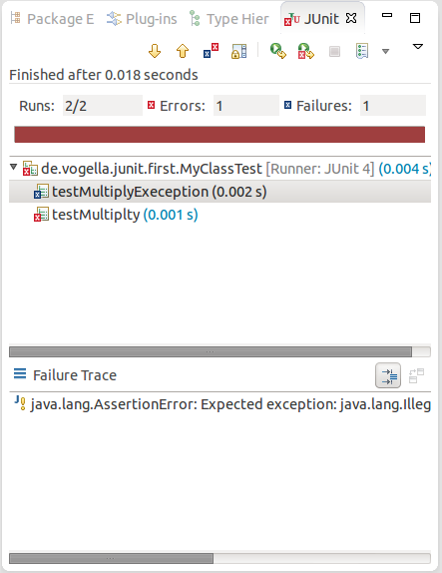

By default, this view shows all tests. You can also configure, that it only shows failing tests.

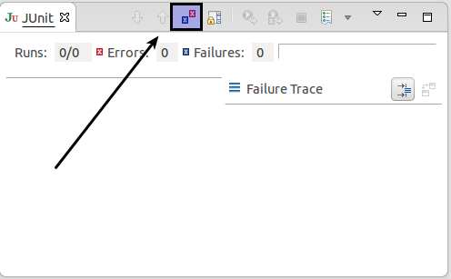

You can also define that the view is only activated if you have a failing test.

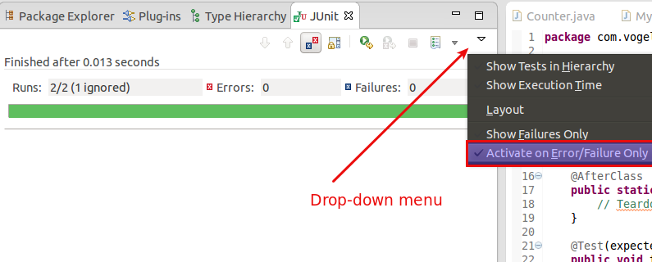

NOTE:Eclipse creates run configurations for tests. You can see and modify these via the Run ▸ Run Configurations…​ menu.

**6.3. Extracting the failed test and stacktraces**

To get the list of failed test, right click on the test result and select *Copy Failure List*. This copies the failed tests and there stack traces into the clipboard.

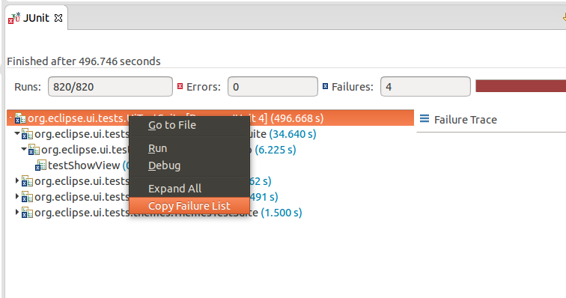

**6.4. JUnit static imports**

Static import is a feature that allows fields and methods defined in a class as public static to be used without specifying the class in which the field is defined.

JUnit assert statements are typically defined as public static to allow the developer to write short test statements. The following snippet demonstrates an assert statement with and without static imports.

// without static imports you have to write the following statement

Assert.assertEquals("10 x 5 must be 50", 50, tester.multiply(10, 5));

// alternatively define assertEquals as static import

import static org.junit.Assert.assertEquals;

// more code

// use assertEquals directly because of the static import

assertEquals("10 x 5 must be 50", 50, tester.multiply(10, 5));

**6.5. Wizard for creating test suites**

You can create a test suite via Eclipse. For this, select the test classes which should be included in suite in the *Package Explorer* view, right-click on them and select New ▸ Other…​ ▸ JUnit ▸ JUnit Test Suite.

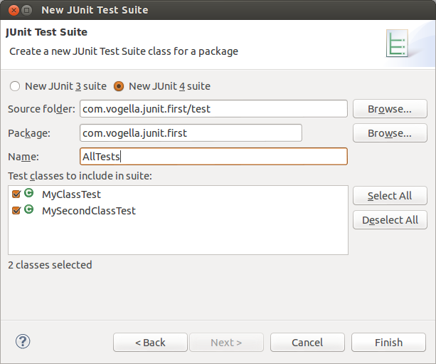

**6.6. Testing exception**

The @Test (expected = Exception.class) annotation is limited as it can only test for one exception. To testexceptions, you can use the following testpattern.

try {

mustThrowException();

fail();

} catch (Exception e) {

// expected

// could also check for message of exception, etc.

}

**6.7. JUnit Plug-in Test**

JUnit Plug-in tests are used to write unit tests for your plug-ins. These tests are executed by a special test runner that launches another Eclipse instance in a separate VM. The test methods are executed within that instance.

**7. Installation of JUnit**

**7.1. Using JUnit with Gradle**

To use JUnit in your Gradle build, add a testCompile dependency to your build file.

apply plugin: 'java'

dependencies {

testCompile 'junit:junit:4.12'

}

**7.2. Using JUnit with Maven**

To use JUnit in your Maven build, add the following dependency to your pom file.

<dependency>

<groupId>junit</groupId>

<artifactId>junit</artifactId>

<version>4.12</version>

</dependency>

**7.3. Using JUnit integrated into Eclipse**

The Eclipse IDE ships with a version of JUnit. If you use Eclipse, no additional download is required.

**7.4. Downloading the JUnit library**

If you want to control the used JUnit library explicitly, download JUnit4.x.jar from the following JUnit website. The download contains the *junit-4.*.jar* which is the JUnit library. Add this library to your Java project and add it to the classpath.

http://junit.org/

**8. Setting Eclipse up for using JUnits static imports**

The Eclipse IDE cannot always create the corresponding static import statements automatically.

You can configure the Eclipse IDE to use code completion to insert typical JUnit method calls and to add the static import automatically. For this open the Preferences via Window ▸ Preferences and select Java ▸ Editor ▸ Content Assist ▸ Favorites.

Use the New Type button to add the following entries to it:

* org.junit.Assert
* org.hamcrest.CoreMatchers
* org.hamcrest.Matchers

This makes, for example, the assertTrue, assertFalse and assertEquals methods directly available in the *Content Assists*.

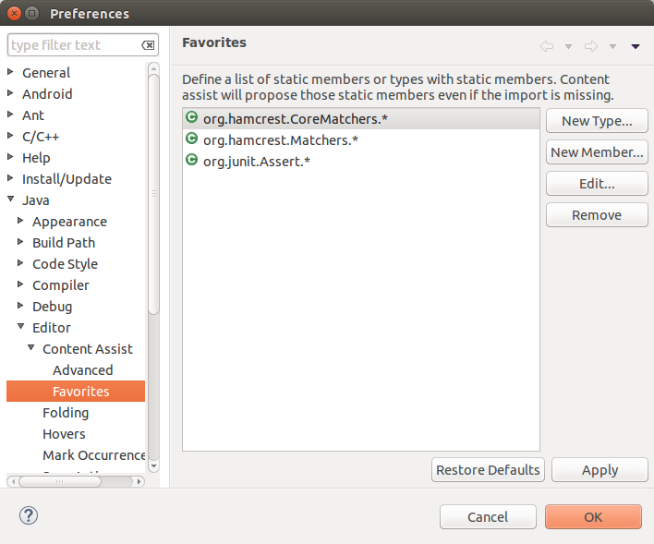

You can now use *Content Assists* (shortcut: Ctrl+Space) to add the method and the import.

**9. Exercise: Using JUnit**

**9.1. Project preparation**

Create a new project called *com.vogella.junit.first*. Create a new source folder *test*. For this right-click on your project, select *Properties* and choose Java ▸ Build Path. Select the *Source* tab.

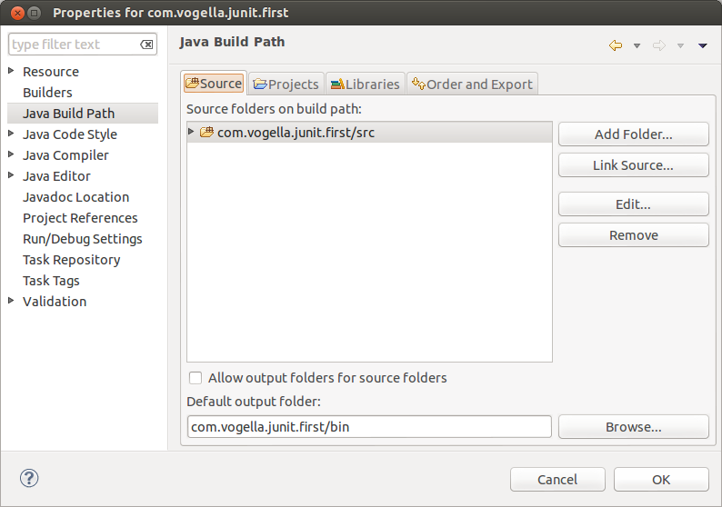

Press the Add Folder button. Afterwards, press the Create New Folder button. Enter *test* as folder name.

The result is depicted in the following screenshot.

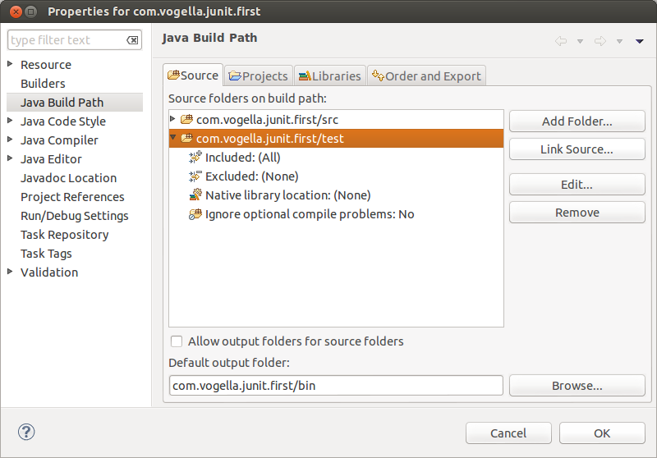

NOTE:You can also add a new source folder by right-clicking on a project and selecting New ▸ Source Folder.

**9.2. Create a Java class**

In the *src* folder, create the com.vogella.junit.first package and the following class.

package com.vogella.junit.first;

public class MyClass {

public int multiply(int x, int y) {

// the following is just an example

if (x > 999) {

throw new IllegalArgumentException("X should be less than 1000");

}

return x / y;

}

}

**9.3. Create a JUnit test**

Right-click on your new class in the *Package Explorer* view and select New ▸ JUnit Test Case.

In the following wizard ensure that the *New JUnit 4 test* flag is selected and set the source folder to *test*, so that your test class gets created in this folder.

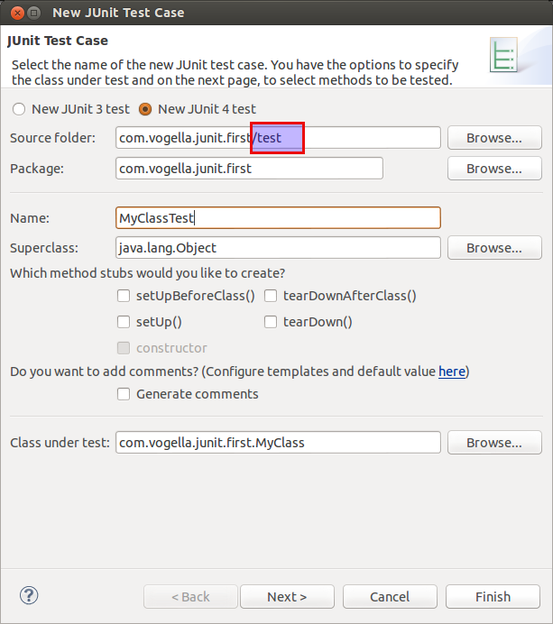

Press the Next button and select the methods that you want to test.

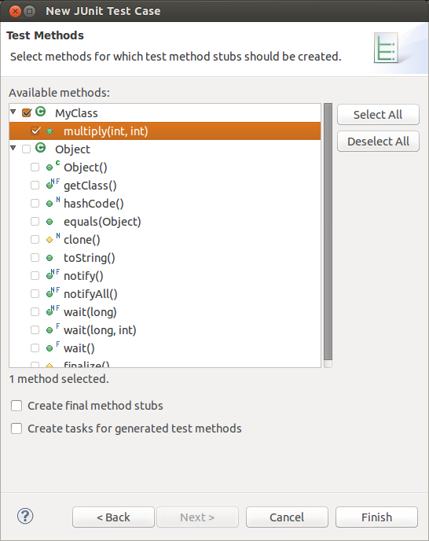

If the JUnit library is not part of the classpath of your project, Eclipse will prompt you to add it. Use this to add JUnit to your project.

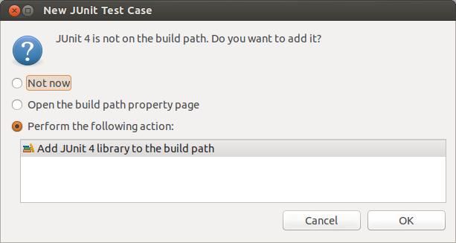

Create a test with the following code.

package com.vogella.junit.first;

import static org.junit.Assert.assertEquals;

import org.junit.AfterClass;

import org.junit.BeforeClass;

import org.junit.Test;

public class MyClassTest {

@Test(expected = IllegalArgumentException.class)

public void testExceptionIsThrown() {

MyClass tester = new MyClass();

tester.multiply(1000, 5);

}

@Test

public void testMultiply() {

MyClass tester = new MyClass();

assertEquals("10 x 5 must be 50", 50, tester.multiply(10, 5));

}

}

**9.4. Run your test in Eclipse**

Right-click on your new test class and select Run-As ▸ JUnit Test.

Run JUnit test in Eclipse

The result of the tests are displayed in the JUnit view. In our example one test should be successful and one test should show an error. This error is indicated by a red bar.

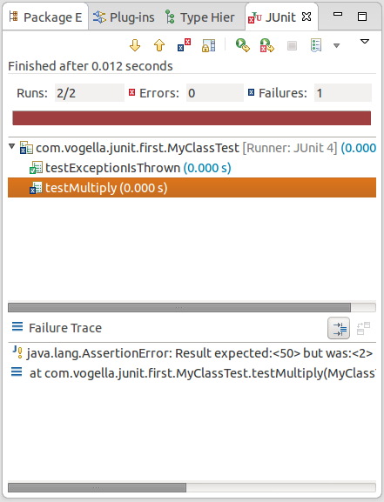

The test is failing, because our multiplier class is currently not working correctly. It does a division instead of multiplication. Fix the bug and re-run the test to get a green bar.

**10. Advanced JUnit options**

**10.1. Parameterized test**

JUnit allows you to use parameters in a tests class. This class can contain one test method and this method is executed with the different parameters provided.

You mark a test class as a parameterized test with the @RunWith(Parameterized.class) annotation.

Such a test class must contain a static method annotated with the @Parameters annotation. That method generates and returns a collection of arrays. Each item in this collection is used as parameter for the test method.

You can use the @Parameter annotation on public fields to get the test values injected in the test.

The following code shows an example for a parameterized test. It tests the multiply() method of the MyClass class which is included as inner class for the purpose of this example.

package testing;

import org.junit.Test;

import org.junit.runner.RunWith;

import org.junit.runners.Parameterized;

import org.junit.runners.Parameterized.Parameters;

import java.util.Arrays;

import java.util.Collection;

import static org.junit.Assert.assertEquals;

import static org.junit.runners.Parameterized.*;

@RunWith(Parameterized.class)

public class ParameterizedTestFields {

// fields used together with @Parameter must be public

@Parameter

public int m1;

@Parameter (value = 1)

public int m2;

// creates the test data

@Parameters

public static Collection<Object[]> data() {

Object[][] data = new Object[][] { { 1 , 2 }, { 5, 3 }, { 121, 4 } };

return Arrays.asList(data);

}

@Test

public void testMultiplyException() {

MyClass tester = new MyClass();

assertEquals("Result", m1 * m2, tester.multiply(m1, m2));

}

// class to be tested

class MyClass {

public int multiply(int i, int j) {

return i *j;

}

}

}

Alternatively to using the @Parameter annotation you can use a constructor in which you store the values for each test. The number of elements in each array provided by the method annotated with @Parameters must correspond to the number of parameters in the constructor of the class. The class is created for each parameter and the test values are passed via the constructor to the class.

package de.vogella.junit.first;

import static org.junit.Assert.assertEquals;

import java.util.Arrays;

import java.util.Collection;

import org.junit.Test;

import org.junit.runner.RunWith;

import org.junit.runners.Parameterized;

import org.junit.runners.Parameterized.Parameters;

@RunWith(Parameterized.class)

public class ParameterizedTestUsingConstructor {

private int m1;

private int m2;

public ParameterizedTestUsingConstructor(int p1, int p2) {

m1 = p1;

m2 = p2;

}

// creates the test data

@Parameters

public static Collection<Object[]> data() {

Object[][] data = new Object[][] { { 1 , 2 }, { 5, 3 }, { 121, 4 } };

return Arrays.asList(data);

}

@Test

public void testMultiplyException() {

MyClass tester = new MyClass();

assertEquals("Result", m1 * m2, tester.multiply(m1, m2));

}

// class to be tested

class MyClass {

public int multiply(int i, int j) {

return i *j;

}

}

}

If you run this test class, the test method is executed with each defined parameter. In the above example the test method is executed three times.

A more flexible and easier to write approach is provided by the JUnitParams from <https://github.com/Pragmatists/JUnitParams>.

**10.2. JUnit Rules**

Via JUnit rules you can add behavior to each tests in a test class. You can annotate fields of type TestRule with the @Rule annotation. You can create objects which can be used and configured in your test methods. This adds more flexibility to your tests. You could, for example, specify which exception message you expect during the execution of your test code.

package de.vogella.junit.first;

import org.junit.Rule;

import org.junit.Test;

import org.junit.rules.ExpectedException;

public class RuleExceptionTesterExample {

@Rule

public ExpectedException exception = ExpectedException.none();

@Test

public void throwsIllegalArgumentExceptionIfIconIsNull() {

exception.expect(IllegalArgumentException.class);

exception.expectMessage("Negative value not allowed");

ClassToBeTested t = new ClassToBeTested();

t.methodToBeTest(-1);

}

}

JUnit already provides several useful rule implementations. For example, the TemporaryFolder class allows to setup files and folders which are automatically removed after each test run.

The following code shows an example for the usage of the TemporaryFolder implementation.

package de.vogella.junit.first;

import static org.junit.Assert.assertTrue;

import java.io.File;

import java.io.IOException;

import org.junit.Rule;

import org.junit.Test;

import org.junit.rules.TemporaryFolder;

public class RuleTester {

@Rule

public TemporaryFolder folder = new TemporaryFolder();

@Test

public void testUsingTempFolder() throws IOException {

File createdFolder = folder.newFolder("newfolder");

File createdFile = folder.newFile("myfilefile.txt");

assertTrue(createdFile.exists());

}

}

For more examples of existing rules see <https://github.com/junit-team/junit4/wiki/Rules>.

**10.3. Writing custom JUnit rules**

To write your custom rule, you need to implement the TestRule interface. This interface defines the apply(Statement, Description) method which must return an instance of Statement. Statement represent the tests within the JUnit runtime and Statement#evaluate() run these. Description describes the individual test. It allows to read information about the test via reflection.

The following is a simple example for adding a log statement to an Android application before and after test execution.

package testing.android.vogella.com.asynctask;

import android.util.Log;

import org.junit.rules.TestRule;

import org.junit.runner.Description;

import org.junit.runners.model.Statement;

public class MyCustomRule implements TestRule {

private Statement base;

private Description description;

@Override

public Statement apply(Statement base, Description description) {

this.base = base;

this.description = description;

return new MyStatement(base);

}

public class MyStatement extends Statement {

private final Statement base;

public MyStatement(Statement base) {

this.base = base;

}

@Override

public void evaluate() throws Throwable {

System.

Log.w("MyCustomRule",description.getMethodName() + "Started" );

try {

base.evaluate();

} finally {

Log.w("MyCustomRule",description.getMethodName() + "Finished");

}

}

}

}

To use this rule, simple add a field annotated with @Rule to your test class.

@Rule

public MyCustomRule myRule = new MyCustomRule();

**10.4. Categories**

It is possible to define categories of tests and include or exclude them based on annotations. The following example is based on the [JUnit 4.8 release notes](https://github.com/junit-team/junit/blob/master/doc/ReleaseNotes4.8.md).

public interface FastTests { /* category marker */

}

public interface SlowTests { /* category marker */

}

public class A {

@Test

public void a() {

fail();

}

@Category(SlowTests.class)

@Test

public void b() {

}

}

@Category({ SlowTests.class, FastTests.class })

public class B {

@Test

public void c() {

}

}

@RunWith(Categories.class)

@IncludeCategory(SlowTests.class)

@SuiteClasses({ A.class, B.class })

// Note that Categories is a kind of Suite

public class SlowTestSuite {

// Will run A.b and B.c, but not A.a

}

@RunWith(Categories.class)

@IncludeCategory(SlowTests.class)

@ExcludeCategory(FastTests.class)

@SuiteClasses({ A.class, B.class })

// Note that Categories is a kind of Suite

public class SlowTestSuite {

// Will run A.b, but not A.a or B.c

}

**11. Mocking**

Unit testing also makes use of object mocking. In this case the real object is exchanged by a replacement which has a predefined behavior for the test.

There are several frameworks available for mocking. To learn more about mock frameworks please see the Mockito tutorial under <http://www.vogella.com/tutorials/Mockito/article.html> or the EasyMock tutorial under <http://www.vogella.com/tutorials/EasyMock/article.html>.